Magento Connector

How to install this module:

1. First copy the module magento_connector into the custom_addons directory(Create if not exist) and update addons patch into the odoo-server.conf file eg: addons_path = /opt/odoo/addons,/opt/custom_addon
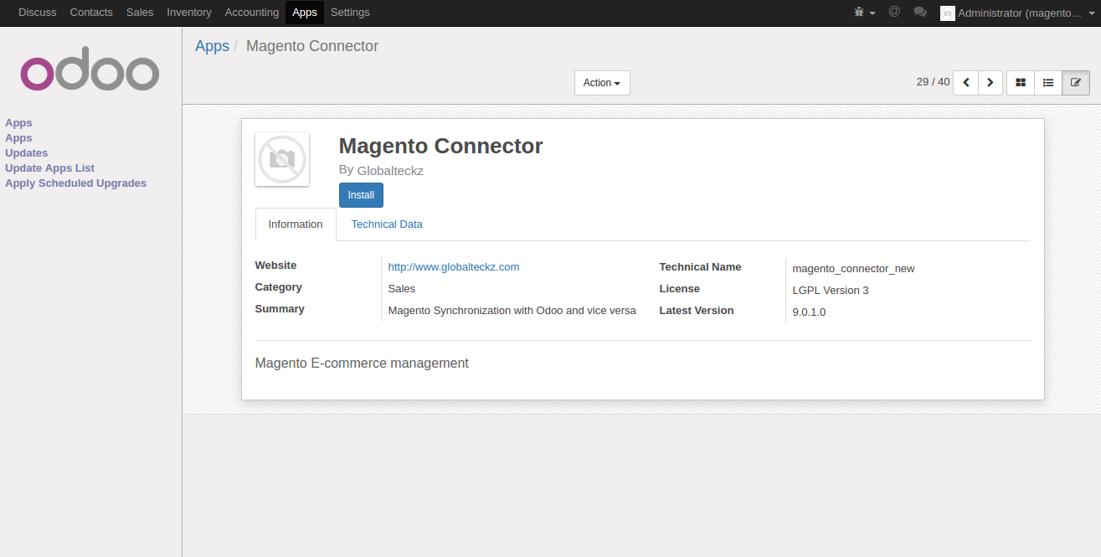
2. click on install button to install module :magento_connector

3. Once the installation is done, firstly we have to create web services and web roles in magento backend for using api to connect with Odoo.

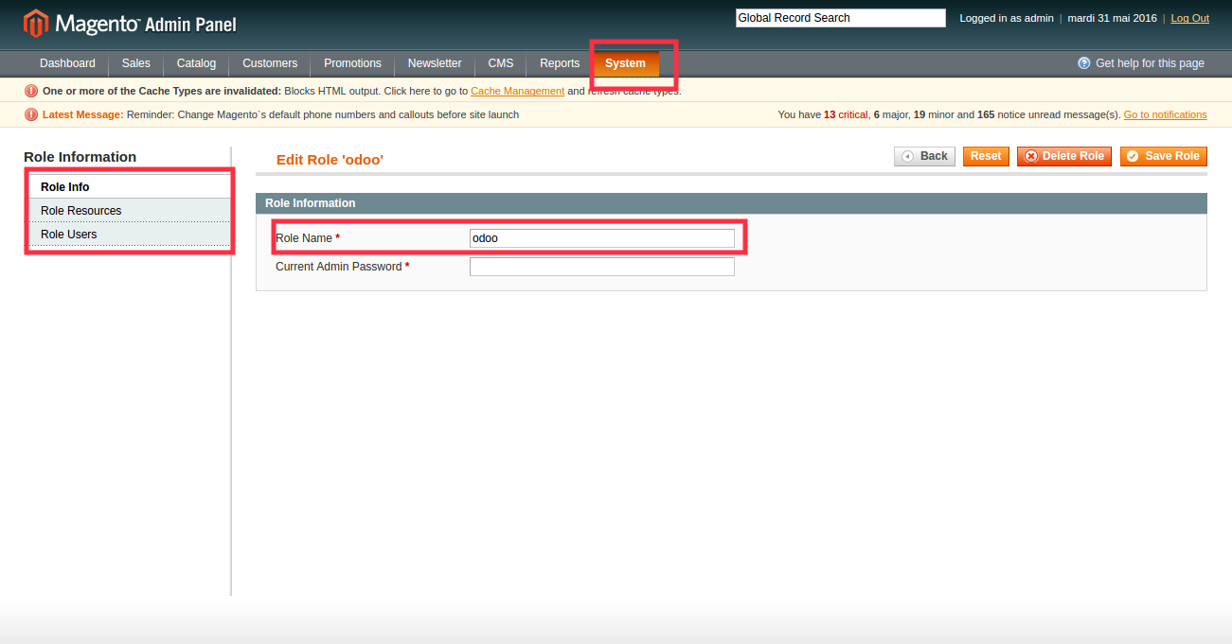
Go to system > Web Services > Soap/XMLRPC Roles and create an new Soapn Role and select and all in role resources

Once web role is created then create web services by going to
system > Web Services > Soap/XMLRPC Users and create a new user and assign the above create role in the user

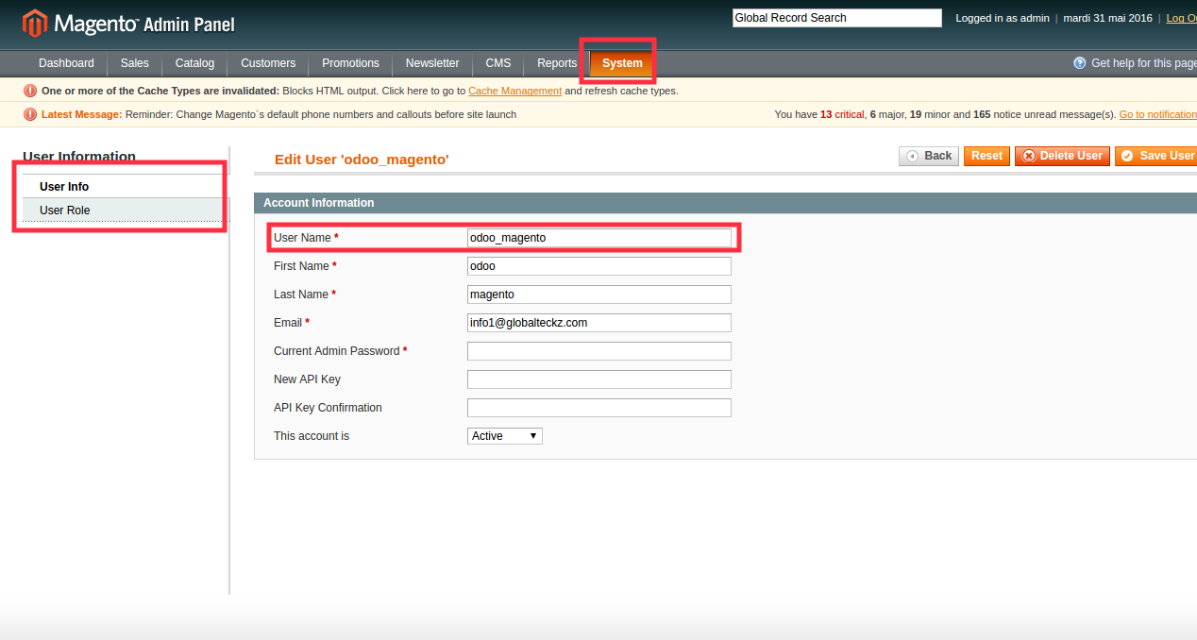

Afer the role is created remember the Username and the API Key which you used to create the user
as it will be used to connect with api in Odoo

Magento – Odoo – Connection

Step1 – Go to magento menu in Odoo and use configuration sub menu and select magento instance

and click on create

Step2 – Insert the required fields as described below

Name – give any name to identify the instance
Location – Insert the Magento Url e.g www.test.com/ or www.test.com/index.php
User Name – Fill the username i.e Web service user
Password – put the password i.e API key which used to create the user

Rest of the fields select as per you requirement

Step3 – Testing the connection of the instance which you created. There is a button on the header of

part of the instance, click on that and wait for the result. There are two possibilty

> Test Connection Succesfull, You can procees with your synchronization, It means your
connection is proper

> Test Connection failed, please check your credentials, It means the credentials entered i.e

location, username, password the information entered is not proper. Correct the details

details and move ahead once the connection test is successful.

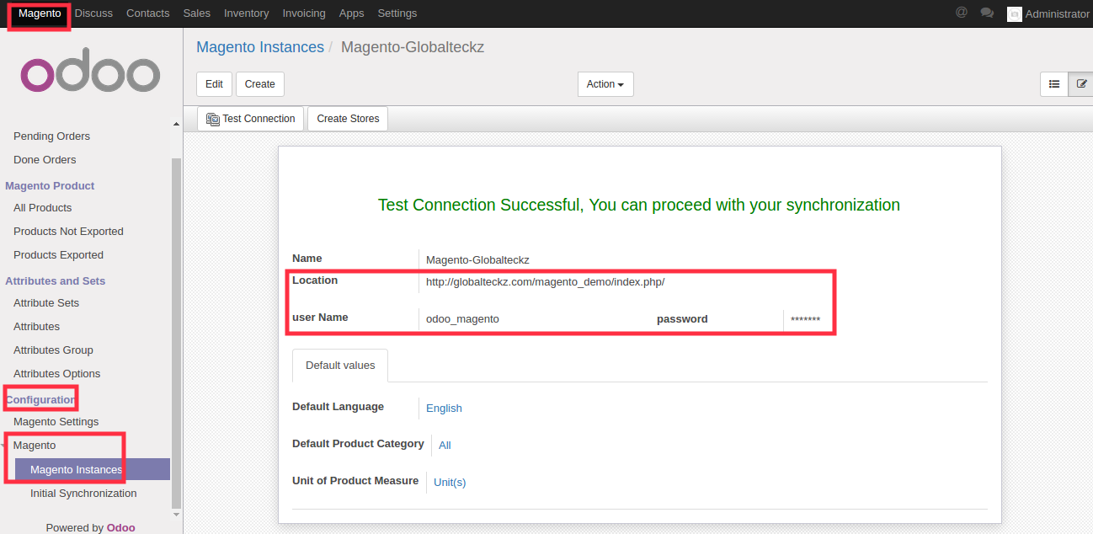

Creating Store

Once the connection test is successfull next to it there will be Create Store button visible, click on that and all the magento store will be created in Odoo. To see the store created in Odoo go to
settings > users > admin and enable the multi store sync group and there will be a menu below magento Instance as Magento Store, you can view all the stores there.

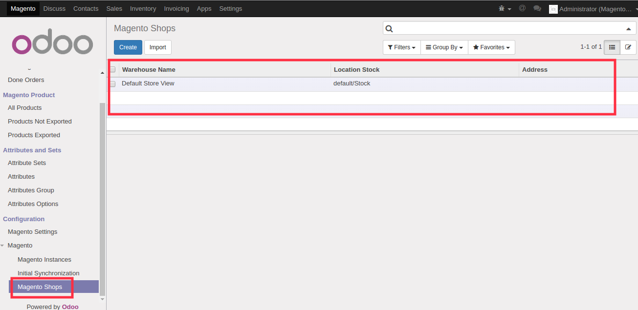
Importing Data from Magento to Odoo

1.Import Attribute Set

Importing of Attribute Set is as simple as clicking the button. Below magento instnace menu click on button Import attribute set and all data will be imported to Odoo and can be visible under sub-menu Attributes and Sets in attribute sets.

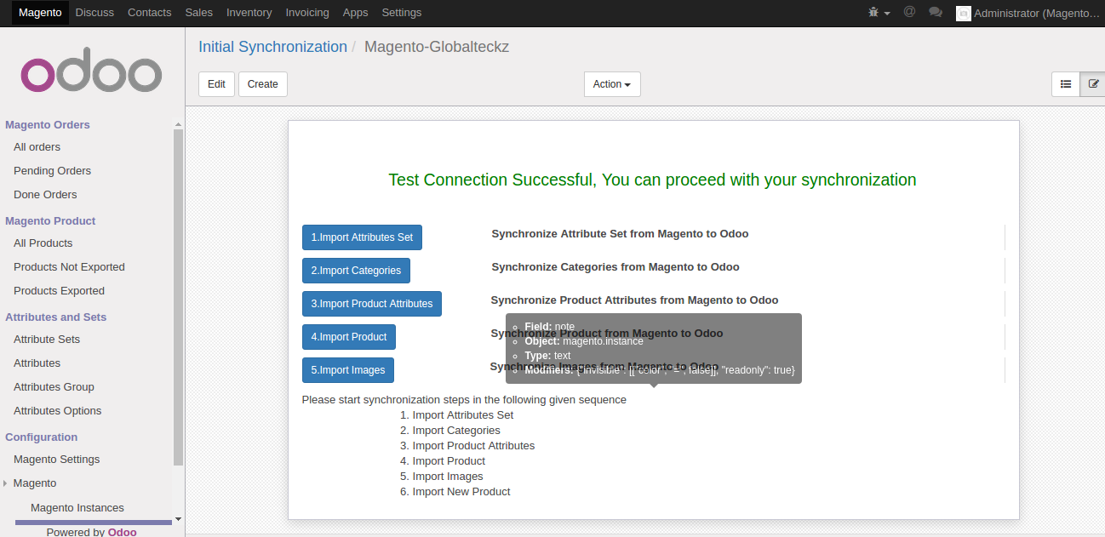
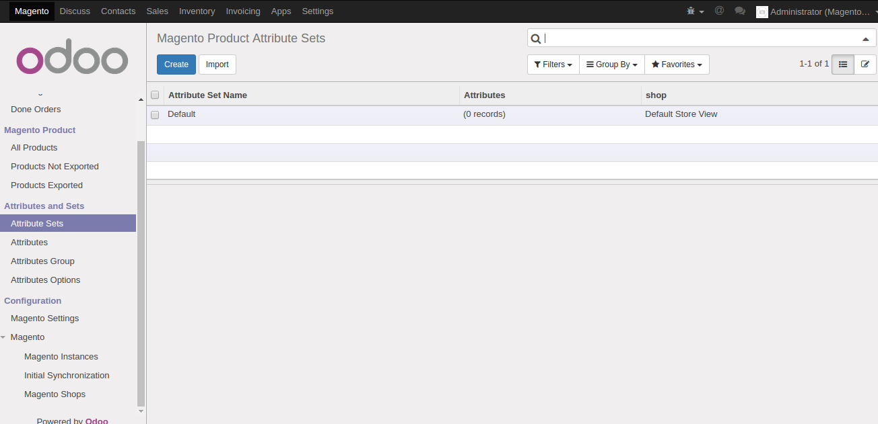

2.Import Categories

After Imporing attribute sets there is next button import categories just below attribute set, just click all categroies will be imported to Odoo

3.Import Product Attributes

When categories are completed click on the next button i.e Import product Attributes, all the product attributes from magento will be imported to Odoo

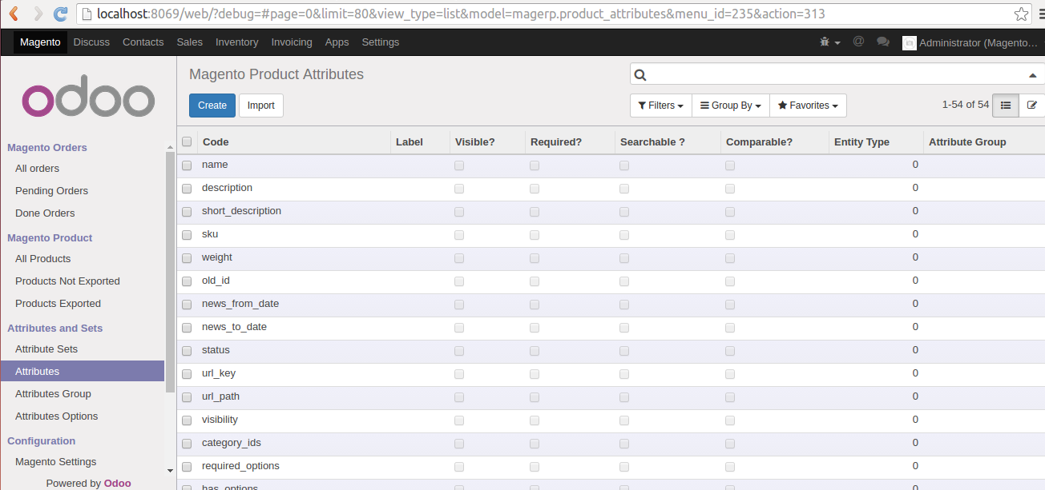
4.Import Products

After completing all the three process i.e attribute sets, categories, product attributes next is to imoport the products from magento, click on the very next button after product attributes which import product. All the products will be imported to Odoo.

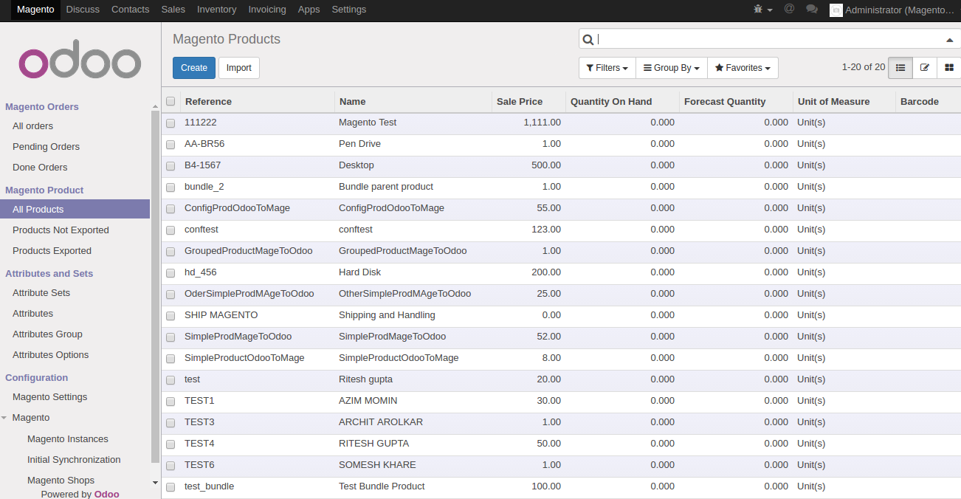

5.Import Images

When product are completely imported, now import images for all the above imported products, click on the next button of Import Images.

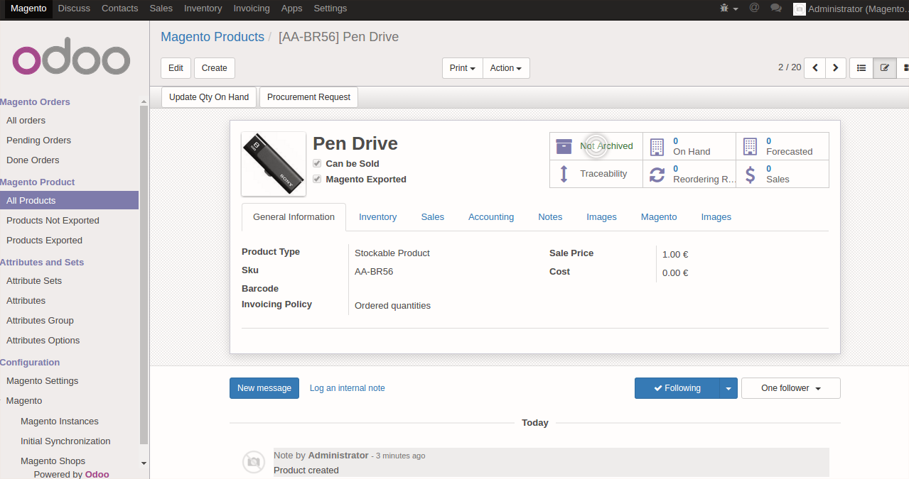

6.Import Customrer group and Customer

All the product are imported along with images. Lets move to now customers and orders. Frist thing is to Import the customer group from magento. Go to Magento Shop Menu below instance menu and open the shop record and if you have multiple shops repeat the process for every shop. There is a tab of Manage customers, click on Import Customer group and then on Import Customer all the data will be sync to Odoo.

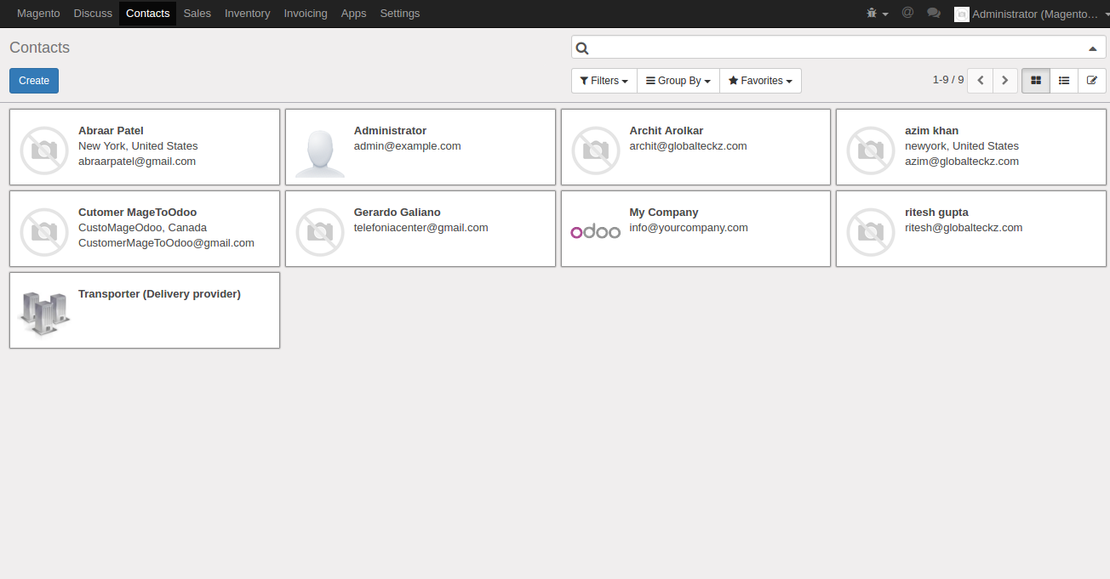
7. Import Orders

On the same form of Manage Customer there is tab Manage Orders. Edit the form menu and you will find a date just next to the import orders button. Just select the date from which you want to import the product and save the form. After selecting date click on Import Orders button and all the orders from that will be imported.

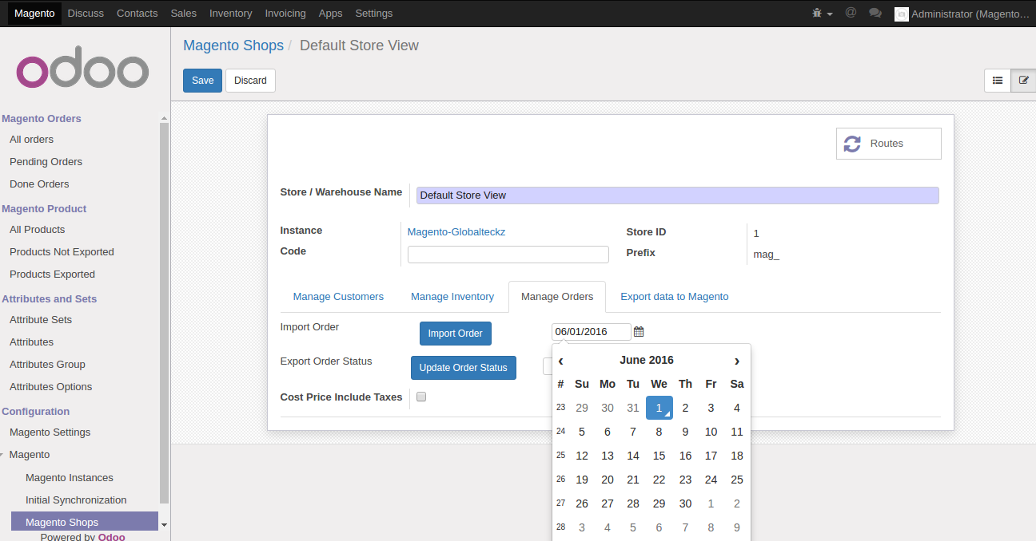
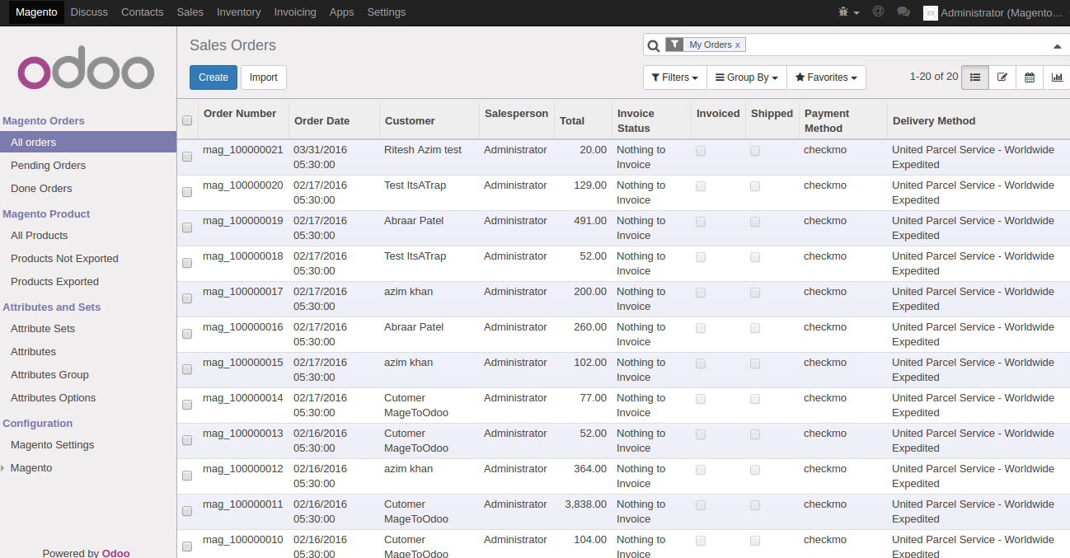

8. Import Stock/Inventory

It is very simple to import stock. Just next to Manage Customer there is another tab Manage Inventory, in that there is button Import Stock just click on that and the products inventory having equal to and greater than zero will be imported.

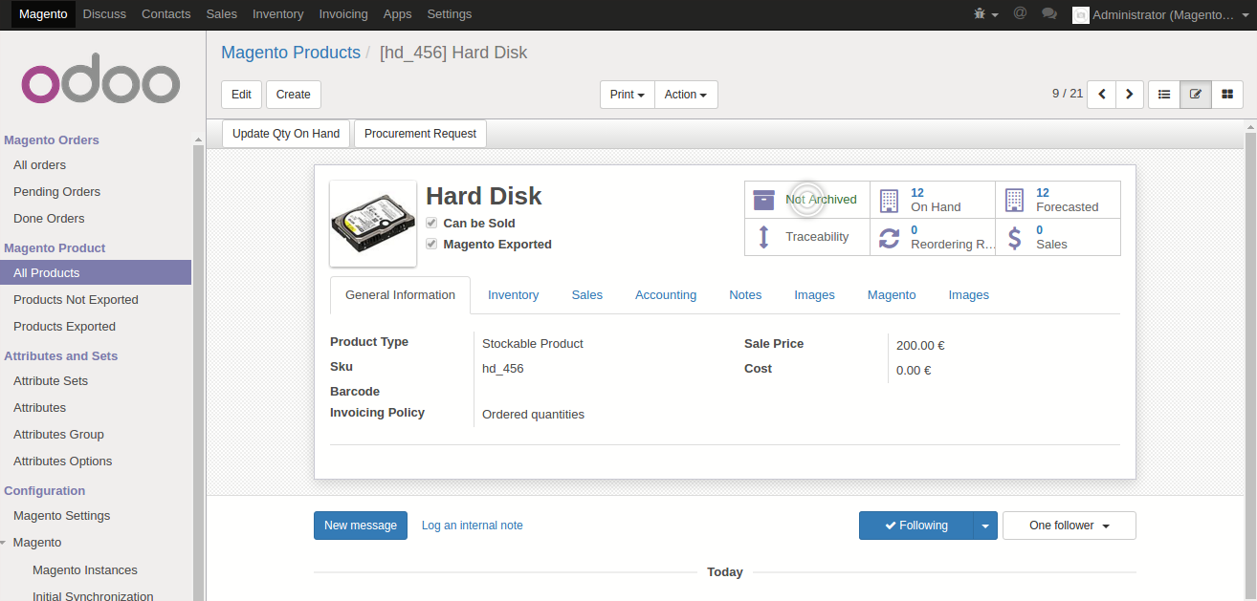

Exporting Data From Odoo To Magento

1.Export Stock

Exporting stock from Odoo to magento is also possible in this Magento-Odoo Connector. To Export the stock from Odoo to Magento go to Magento > Configuration > magento > magento Shop open the record and find Manage Inventory tab. In that you will find a button Export Stock, click on that all product stock will export to Magento.

2. Export Order Status

In the same manner like export stock is possible exporting order status is also possible. There is tab in magento shop Manage Order, click on the button export order status and you are done.

3.Export Product and Images

There two types of product one which are available on Magento and as well as Odoo, other type of product which only there in Odoo.
> To export product that are available on both the medium go to Export data to Magento tab and the
very first button is export products. By clicking this button products which are available in magento will be updated if any changes made in Odoo.

> To export the product only there in Odoo, click on the button Export New Product. With the help of this button the products which are not available in Magento and there Odoo will be exported and can be visible in Magento.

> The last thing is to Export Images. If we add new products or change images of existing product it is possible to export the images on the click of Export Images button in Export data to magento tab and the effect will be visible in Magento.

Magento Configuration Settings

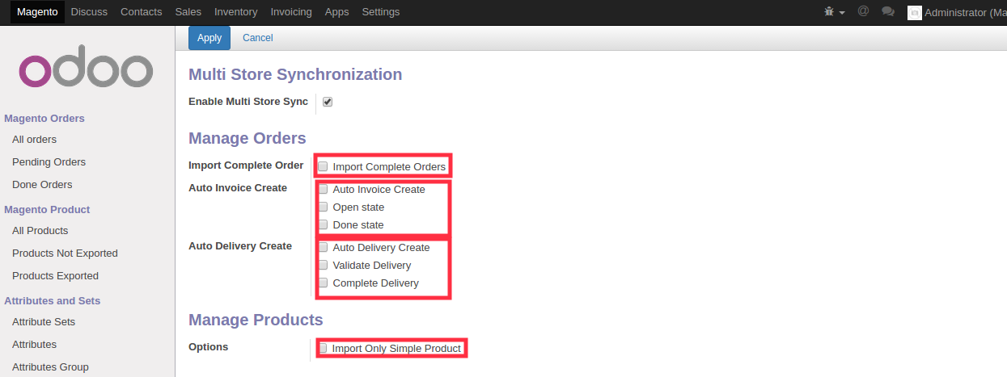

1. Import Complete Orders

When you select this option and apply then while Importing Orders as shown above in the document only orders having complete status on Magento order will be imported. This option is very helpful when you want to import the old orders while configuring magento in Odoo.

2. Auto Invoice Create

> The first option is Auto Invoice Create this will help to create invoice of the order while importing from magento irrespective of the order status.

> The second option is to Open state this will help you create the invoice in open state the next stage after draft state.

> The last option will help you to omplete the Invoice in done state i.e the invoice will be validated and paid automatically in Odoo while importing Orders from Magento

3. Auto Delivery Create

> The first option is Auto Delivery Create this will help to create delivery of the order while importing from magento irrespective of the order status.

> The second option is to Validate Delivery Order this will help you to validate the delivery order.

> The last option will help you to complete the Delivery order automatically while importing orders

4.Manage Products

When you want to import only simple products, select this option and only simple product will be imported.

5. Automation

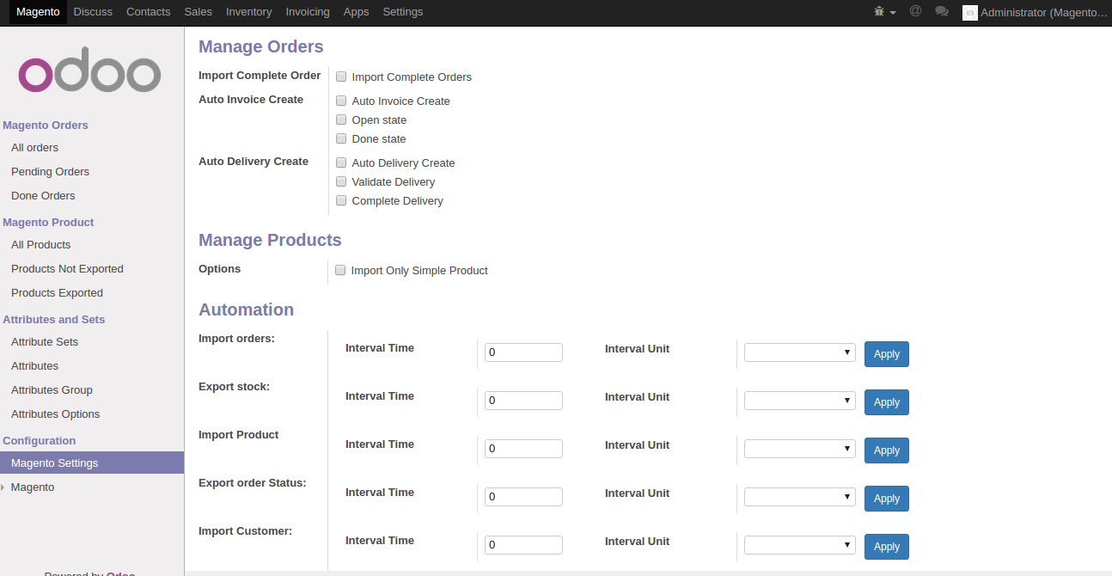
Automation will create an easy of work when you are familiar with Odoo and it will help you to make your work much easier. You only need to set the Interval Time and Inverval Unit and apply with this that functionality will automatically run within the set Interval Time. The Automation is available for Importing Orders, Exporting Stock, Importing Products, Export Order Status, Importing Customer

Above explained Configuration will give you the flexibity to handle you operations as per your mode of work and will make your work much easier and accurate

